Contents

Planning Analysis Sheet 3

1. Design of Website 3

Website Link 3

Website Title 3

Website Goal: 3

Wireframe: 3

Website Structure: 4

4

Source of images: 4

Styles Sheet: 4

Home Page 4

About Us Page 4

Contact Us Page 5

Membership Page 5

General Notes on Website Design: 5

2. Testing & Check of Web Accessibility & Performance 5

Testing with Desktop 5

Testing with Mobile 5

Testing with Tablet 6

Web Accessibility 6

SilkTide 6

Page Speed Insights 6

3. Search Engine Optimisation 8

Screaming Frog 8

HTML Validation 9

CSS Validation 9

Google Search Central 9

References 11

# Planning Analysis Sheet

The Project was split into three phases.

1. Design of Website
2. Testing of Website on different Browers and Devices
3. Search Engine Optimisation (SEO)

# Design of Website

## Website Link

The website is accessible at

## Website Title

Animal Management

## Website Goal:

The goal of this website is to provide a full E2E view of Animal Management so that the farmer can make the best decisions for his farm business but also for the welfare of his/her herd.

## Wireframe:

The wireframe is a sketch or blueprint of the site, it shows the structure of the basic page including the elements.

* Header
* Navigation
* Content
* Footer and Image Locations

In general, the website follows the Responsive Layout with media queries as outlined in page 38/50 of the Unit 7 slides.

*Figure 1 Wireframe Layout of Website*

## Website Structure:

Figure 2 shows the basic structure of the FarmAI Site Layout

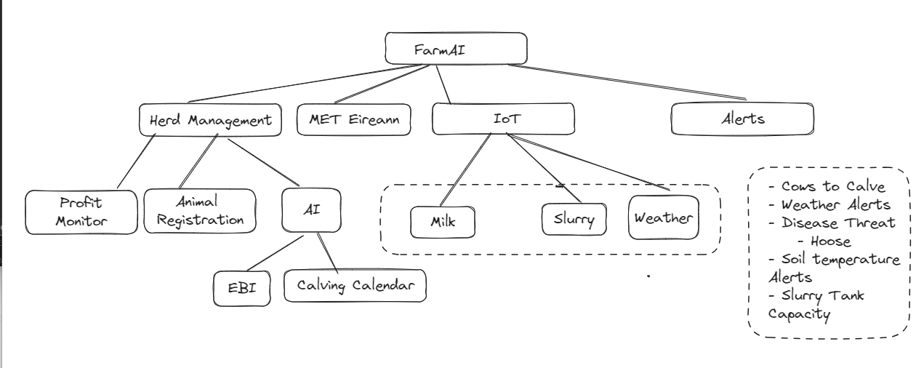

*Figure FarmAI Site Diagram*

## Source of images:

* TBA

## Styles Sheet:

* A single external style sheet was used as specified in the assignment.

## Home Page

1. The Home page include an introduction and Welcome to the Website.

## About Us Page

1. The About Us Page describes who we are and the mission statement of the website.

## Contact Us Page

## Membership Page

## Register Animal

This page has the form that includes a Form to Register an animal at birth or add any animal. In the first project, I used the standard Form Layout. But this time, I have made the Form more responsive having read Chapter 19 (Learning Web Design, Robbins) by making each <li> item more responsive. I’ve used Flexbox to make the labels stack on top of their respective inputs when and fieldsets on narrow screens, so that there is no wasted space.

By default, browsers may use different fonts at different sizes for various input types. We would prefer that all inputs have the same font as the surrounding text on the page, you can force form elements to inherit font settings. (Pg. 548)

*/* Corodinated Fonts across for all form elements. Pg. 548*/*

button, input, select, textarea {

    font-family: inherit;

    font-size: 100%;

}

1. Consider an option where the main is the parent is a flexbox, form is a flexitem for this form like the [Design A Cool Responsive Registration Form Using HTML & CSS Flexbox - YouTube](https://www.youtube.com/watch?v=JpNr5aEIxSI) used body to be the parent item and the Form to be the Flex item. But I will have other elements so it would be better to have main as flexbox and Form as Flexitem.
2. The good thing about this is that building a Form using Flexbox means that w edon’t have to use media queries.
3. [CSS Flexbox Responsive Form Layout With Source Code (softauthor.com)](https://softauthor.com/css-flexbox-responsive-registration-form-with-source-code/)

## Styles.css

## General Notes on Website Design:

1. One style sheet for all Web pages as the look must be consistent across all HTML pages.
2. The Assignment sheet has stated that popular browsers including Chrome, Edge, Firefox must render each page correctly. Based on this, the submitted project may not render well for IE users. Only a small number of browsers support Internet Explorer, “1.5% of browser traffic in 2017 was using Internet Explorer versions 8 and earlier” (Robins, 2017)
3. For the sidebar, chose to use the ***<aside>*** HTML element as it is semantically appropriate for the content, which are supplementary links that are not directly related to the content but provides additional information. The content in the side bar has a semantic relationship with the main content. <div> would be used if the sidebar was for layout and styling.
4. The largest width for smart phones is 412px, so this is the default.
5. ***Width= device-width*** on all html pages. This tells the browser to set the width of the viewport to the width of the device screen. The initial scale is set to 1 (100%)
6. Used internal links to navigate in the home page. Add a link back to the top of the Home page to make navigation easier.
7. Used the information in <https://stackoverflow.com/questions/6885099/css-html-javascript-tricks-to-print-a-web-page-without-images> to prevent printing of the images to avoid unnecessary use of color ink. Also prevent the printing of the aside links as these links while related to soccer would provide any value in a printed-out form. Also stopped the printing the ***<nav>*** as advised in lecture notes. <figure> elements are also not printed.

# Testing & Check of Web Accessibility & Performance

The project was tested on browsers and devices below.

## Testing with Desktop



*Figure 3 Browser Testing Results for Desktop*

## Testing with Mobile

|  |  |  |  |  |  |
| --- | --- | --- | --- | --- | --- |
|  | iPhone(portrait) | iPhone(landscape) | Android(Potrait) | Android(Landscape) | 3G Coverage (iPhone) |
| Page | Safari | | Chrome | | Safari |
| Index.html | Ok | Ok | Ok | Ok | Ok |
| About Us | OK | OK | OK | OK | OK |
| Contact Us | OK | OK | OK | OK | OK |
| Membership | OK | OK | OK | OK | OK |

*Figure 4 Browser Testing Results for Mobile*

## Testing with Tablet

|  |  |
| --- | --- |
| Ipad (potrait) | Ipad (landscape) |
| Safari | |
| Note 1 | Note 1 |
| Note 1 | Note 1 |
| Note 1 | Note 1 |
| Note 1 | Note 1 |

*Figure 5 Browser Testing Results for iPad*

Note:

1. There was one issue with the Safari on IPad running Safari where the header was being extended. The IPad was running on older versions of IOS, 12.5.7. But this was not happening with the Safari Browers using the “Toggle Device Toolbar.

## Web Accessibility

Ran the WAVE tool on website on all four pages. One Contrast Error across the four pages. It is the ‘Embed from Getty Images”. Investigating how to change this ‘grey’ font with Javascript.

## SilkTide

Ran the Silktide tool on the four pages, just focusing on Blindness. Overall the pages read like were meant to, so semantically the site is setup well.

## Page Speed Insights

Below are the result for from pagespeed.web.dev carried out on the 30th September.

|  |  |  |  |  |
| --- | --- | --- | --- | --- |
|  | **Mobile** | | | |
| Page | Performance(%) | Accessibility(%) | Best Practices(%) | SEO(%) |
| index.html | 97 | 86 | 100 | 100 |
| About_Us,html | 100 | 100 | 100 | 100 |
| Contact_US.html | 100 | 100 | 100 | 100 |
| Memership.HTML | 100 | 100 | 100 | 100 |

*Figure 6 PageSpeed Results for Mobile. See Note 1 below.*

|  |  |  |  |  |
| --- | --- | --- | --- | --- |
|  | **Desktop** | | | |
| Page | Performance(%) | Accessibility(%) | Best Practices(%) | SEO(%) |
| index.html | 100 | 86 | 100 | 100 |
| About_Us,html | 100 | 100 | 100 | 100 |
| Contact_US.html | 100 | 100 | 100 | 100 |
| Memership.HTML | 100 | 100 | 100 | 100 |

*Figure 7 PageSpeed Results for Desktop. See Note 1 below.*

Note 1: The main page(index.html) is performing poorly as shown in the figure below.

# Search Engine Optimisation

## Screaming Frog

From lecture 11, important to have meta tags on each page. So used the name=Description” meta tag to describe each page in a meaningful way to increase chances of search engines finding the site.

*Figure 6 Screamingfrog*

*Figure7 Screamingfrog, Each html page has a meta description and is less than 150 characters.*

Added;

<link rel="canonical" href="https://ivcos.github.io/soccer_fans_project/membership.html">

ChatGPT

* **SEO**: Using **rel="canonical"** helps prevent SEO issues related to duplicate content and ensures that search engines index the right URL, which can improve search rankings.
* **User Experience**: It can also improve the user experience by ensuring that users are consistently directed to the preferred version of a page.

Added meta tag to provide a description of the page to improve SEO. I used a sentence in the meta name=”description” rather than individual key terms.

## HTML Validation

SEO is improved if there are no HTML errors. HTML validation completed on <https://validator.w3.org/> for all four files with no errors. All four HTML files passed on the 23/09/2023

## CSS Validation

SEO is improved if there are no CSS errors. CSS Validation passed on the 30/09/2023

## Google Search Central

1. Checked if site was on Google.
2. <https://developers.google.com/search/docs/crawling-indexing/sitemaps/overview>
3. Logged into Google Search Console and uploaded a Google.html file to Github to verify ownership verification of the link. I used the HTML verification method.
4. Sitemap successfully submitted.

*Figure 8 Message that Sitemap was submitted successfully.*

However, was getting an error, saying there was an error as I was loading HTML instead of XML. Generated an XML file using ScreamingFrog.

*Figure 9 ScreamingFrom generated sitemap xml file*

Below is the XML File generated.

<?xml version="1.0" encoding="utf-8"?><!--Generated by Screaming Frog SEO Spider 19.2-->

<urlset xmlns="http://www.sitemaps.org/schemas/sitemap/0.9">

<url>

<loc>https://ivcos.github.io/soccer_fans_project/index.html</loc>

<lastmod>2023-10-01</lastmod>

<changefreq>daily</changefreq>

<priority>1.0</priority>

</url>

<url>

<loc>https://ivcos.github.io/soccer_fans_project/contact_us.html</loc>

<lastmod>2023-10-01</lastmod>

<changefreq>daily</changefreq>

<priority>0.9</priority>

</url>

<url>

<loc>https://ivcos.github.io/soccer_fans_project/Duck&amp;DrakeClub.html</loc>

<lastmod>2023-10-01</lastmod>

<changefreq>daily</changefreq>

<priority>0.9</priority>

</url>

<url>

<loc>https://ivcos.github.io/soccer_fans_project/about.html</loc>

<lastmod>2023-10-01</lastmod>

<changefreq>daily</changefreq>

<priority>0.9</priority>

</url>

<url>

<loc>https://ivcos.github.io/soccer_fans_project/membership.html</loc>

<lastmod>2023-10-01</lastmod>

<changefreq>daily</changefreq>

<priority>0.9</priority>

</url>

</urlset>

Add the file to the project folder and committed to GitHub. Now the sitemap for my site had been successfully submitted.

*Figure 10 sitemap xml file successfully loaded.*

I will continue to monitor Google Search Console to see how my site is performing.

## References

Robbins, J. (2018). Learning Web Design. 5th ed. O’Reilly: CA95472.